|  |  |
| --- | --- |
| Volume of tube (m3) | 5.22 * 10-5 |
| Mass of piston (kg) | 6.528 * 10-3 |
| Cross Section of Tube Area (m2) | 1.54 * 10-4 |

Air Results:

|  |  |  |  |
| --- | --- | --- | --- |
| Absolute Pressure (kPa) | Count 1 (Hz) | Count 2 (Hz) | Count 3(Hz) |
| 100 | 22.2 | 22.65 | 22.23 |
| 90 | 21.65 | 21.36 | 21.4 |
| 80 | 21.16 | 20.9 | 20.15 |
| 70 | 18.74 | 19.82 | 19.48 |
| 60 | 18.73 | 18.74 | 18.03 |
| 50 | 16.19 | 16.9 | 16.03 |
| 40 | 14.15 | 14.7 | 14.7 |
| 30 | 12.13 | 12.34 | 12.39 |

$\frac{d{F_{0}}^{2}}{dP}$ = 0.0050

Calculating Gamma using equation 13 gives a value of 1.4222 for Air.

Helium Results :

|  |  |  |  |
| --- | --- | --- | --- |
| Absolute Pressure (kPa) | Count 1 (Hz) | Count 2 (Hz) | Count 3(Hz) |
| 150 | 29.55 | 28.84 | 28.84 |
| 140 | 27.11 | 27.46 | 27.37 |
| 130 | 26.09 | 25.86 | 25.91 |
| 120 | 24.93 | 25.27 | 25.48 |
| 110 | 23.99 | 24.3 | 23.03 |
| 100 | 23.75 | 22.27 | 22.76 |
| 90 | 21.38 | 22.74 | 21.36 |
| 80 | 21.12 | 21.74 | 21.18 |
| 70 | 20.09 | 20.3 | 20.84 |
| 60 | 19.27 | 19.3 | 18.8 |
| 50 | 17.64 | 16.28 | 16.73 |
| 40 | 16.01 | 15.84 | 15.56 |
| 30 | 15.16 | 14.5 | 14.35 |
| 20 | 13.93 | 14.25 | 13.61 |
| 10 | 13.81 | 13.3 | 14.01 |

$\frac{d{F_{0}}^{2}}{dP}$ = 0.0046

Calculating Gamma using equation 13 gives a value of 1.3141 for Helium.

Nitrogen Results :

|  |  |  |  |
| --- | --- | --- | --- |
| Absolute Pressure (kPa) | Count 1 (Hz) | Count 2 (Hz) | Count 3(Hz) |
| 150 | 29.2 | 28.46 | 29.33 |
| 140 | 26.88 | 26.46 | 26.98 |
| 130 | 25.75 | 26.34 | 25.85 |
| 120 | 24.74 | 25.12 | 25.05 |
| 110 | 24.48 | 24.33 | 23.78 |
| 100 | 23.13 | 23.39 | 22.58 |
| 90 | 22.22 | 21.90 | 21.74 |
| 80 | 19.94 | 19.56 | 20.30 |
| 70 | 19.45 | 19.06 | 18.90 |
| 60 | 18.75 | 18.75 | 18.34 |
| 50 | 16.56 | 16.63 | 16.73 |
| 40 | 14.4 | 14.40 | 13.94 |
| 30 | 13.05 | 13.08 | 12.36 |

$\frac{d{F_{0}}^{2}}{dP}$ = 0.0053

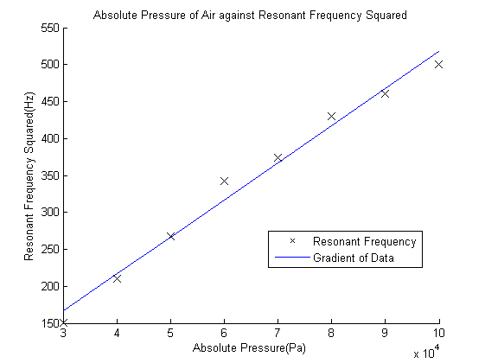Calculating Gamma using equation 13 gives a value of 1.4994 for Nitrogen.

